ROSSES COMMUNITY SCHOOL LEAVING CERT APPLIED NEWSLETTER #1 JAN16

  - Welcome Note
The Rosses Community School have been running the Leaving Cert Applied programme since 2003. In the past twelve years, we have seen many of our students go on to achieve their career goals in many and varied disciplines. Over the coming months, we plan to profile some of our past students to see what they have been getting up to in their chosen careers after leaving the RCS! We also hope to keep you up to date on what’s new with our current students.
pobalscoil na rosANn 15/16
EXAMS
It has been a busy couple of months for the class of 15/16 since starting back to school on September 1st as they are now preparing for their final Leaving Certificate exams next June. Since September they have been working hard on two tasks; Practical Achievement and Contemporary Issue, which will be examined by external examiners from the State Exams Commission at the end of January. The PAT task involves the students learning a new skill in their own time and completing a booklet outlining their progression and skills acquired. Contemporary issues task requires students to conduct and to complete an investigation into, and take action in relation to a contemporary issue of social significance, in the local national or global community.

WORK and SKILLS PROGRAMME
On the 15/10/15 Brian Mc Gonagle, Kathleen Mulvin Brady, LYIT and Elaine Mc Fadden, BITC Ireland gave an information and introductory session to the class. This is the fifth year that the LCA class have taken part in this highly valued and worthwhile programme.
HCT VISIT
On the 5/10/15 Mrs. Conlon (Hotel Catering and Tourism teacher) and the class visited the Clanree Hotel in Letterkenny as part of their Hotel Catering and Tourism elective module.
LYIT
On the 16/11/15 the class had an informative and highly interactive CV and interview session as part of their Work and Skills programme.
RURAL CRIME
The week starting Monday the 16/11/15 proved to be quite a hectic week for the class, with no less than five guest speakers visiting. On Tuesday the 17th, Sergeant Rory Harrison and Ms. Martina Duddy gave a presentation to the class on the setting up of
“Community Text Alert”. On Thursday the 19th, Ms. Nuala Campbell of “Care of the Aged” gave a talk to the class on some of the concerns the elderly in our community face on a daily basis. On Friday the 20th, the final talk and presentation that week was by Sergeant Paul Wallace, Crime Prevention officer for Donegal and Garda Patrick McGlynn, Juvenile Liaison officer. The theme of the excellent presentation was on Rural Crime and this will form the basis of the classes’ Contemporary issues task.
On Monday 30/11/15, another guest speaker, Mrs. Vanessa Clarke, Community Alert Development Officer with “Muintir Na Tire” gave a highly informative multimedia presentation on setting up a community scheme. A lively questions/answers session followed which concluded with the students eager to become involved in raising awareness of this important scheme in their locality. On Tuesday 1/12/15, as part of their Contemporary Issues task the students visited the Maghery Day Centre to meet with the senior citizens and distribute a questionnaire with the purpose of finding out how they, as senior citizens, felt about rural crime and establish if any of them had been affected by it and what they as young citizens in the community can do to help. They were treated to tea and
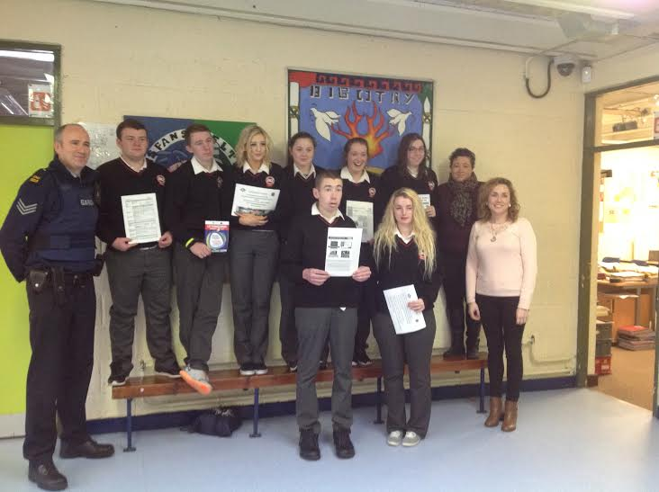
cakes at the centre and thoroughly enjoyed hearing the opinions and stories of such valued members of our community.
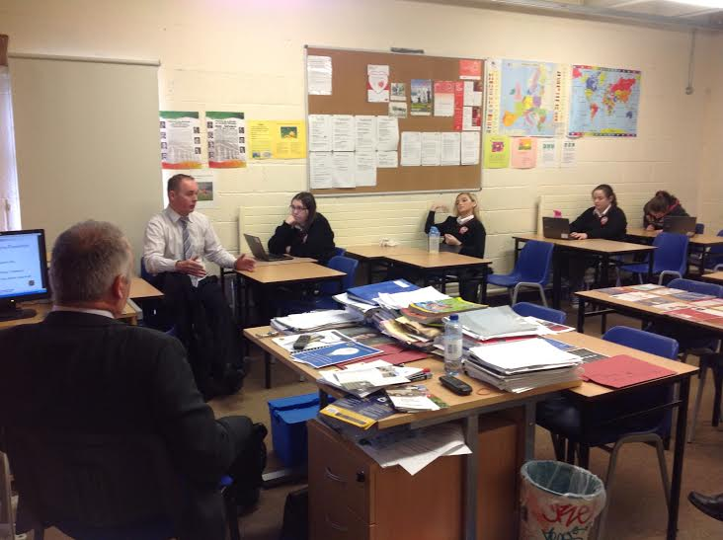
Sgt Rory Harrison, Ms. Martina Duddy with LCA after talk on “Text Alert”
VISIT OUT
On the 10/12/15, the class visited the LYIT for a company overview and site visit. They were met by Brian, Elaine and Kathleen who provided them with goodie bags and gave them an introductory talk about the college. John Andy Bonner then brought them to CoLab, which is the Business Development Centre at the college. The also visited the Students’ Union and the Gym. They finished off their visit with an exciting treasure hunt before being treated to lunch at the college canteen.
SPECIAL GUEST
On the 15/12/15, Donal Byrne, a past LCA student of the RCS who is home from the States visited the students and spoke to them about his career to date. Donal’s full career profile will appear in our next edition, so watch this space!
The class are continuing with their work experience every Wednesday at Hairdressing Salons, Supermarkets Créches and Equestrian Centres.
Sgt Paul Wallace and Garda Patrick McGlynn with LCA after presentation on “Rural Crime”

Hope you have enjoyed catching up with the class of 15/16! Wishing you all a Happy New Year.

